Name: __________________________________ Date: _________________

**Proportions Involving Line Segments**

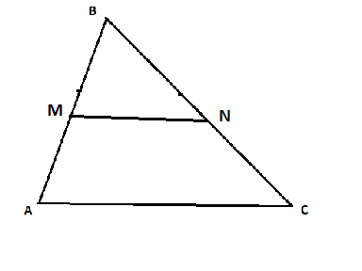

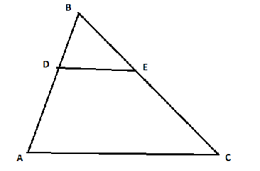

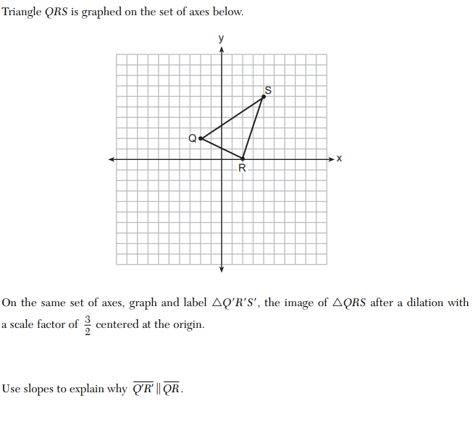

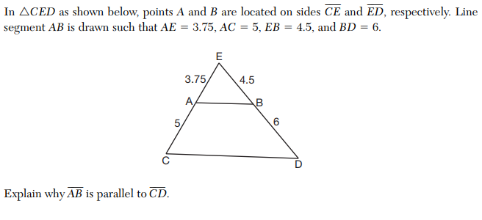

1.

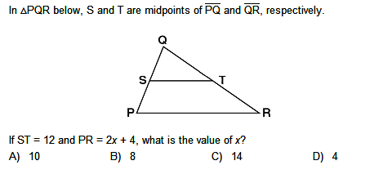

2.

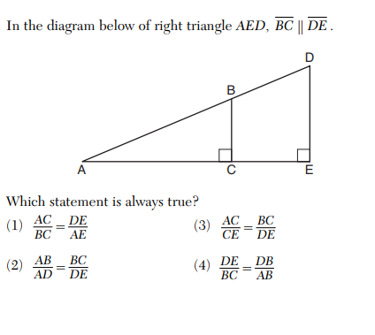

3.

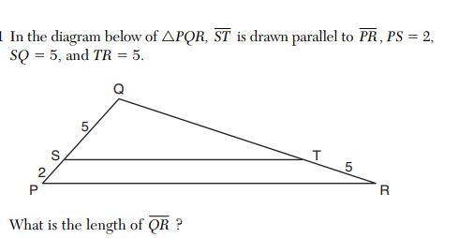

4.

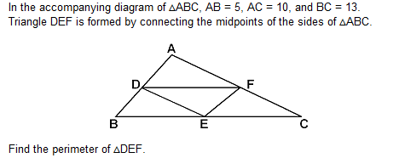

5.

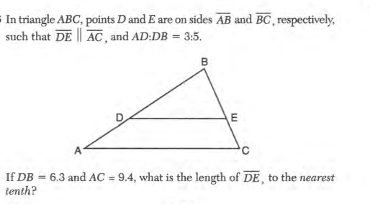

6.

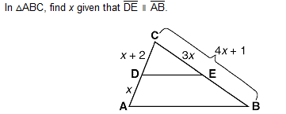

7.

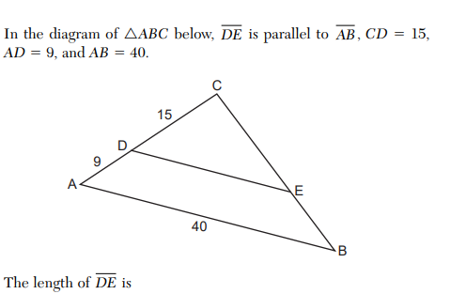

8. In the diagram of  below, , , , and .

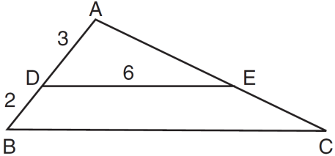

What is the length of ?

9. In , point *D* is on , and point *E* is on  such that . If , , and , what is the length of ?

10.

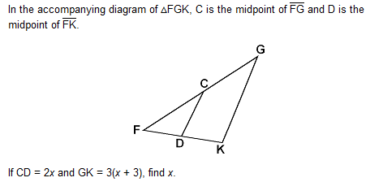

11.

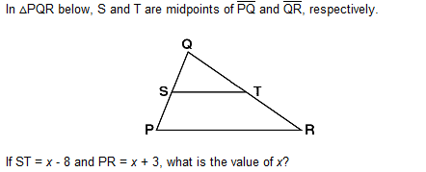

12. In the diagram of  below, .

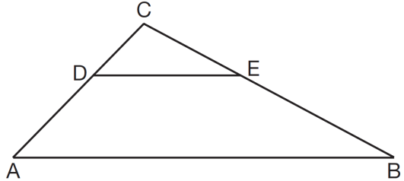

If , , , and , what is the length of ?

13.

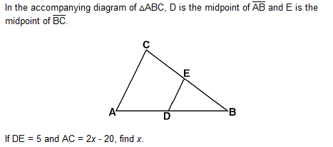

14.



15.

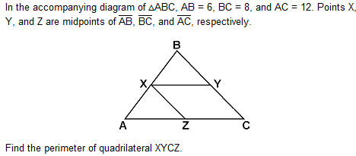

16.



17. In the accompanying diagram, line segment BC is parallel to line segment ED. = 2,  = 4,

and = 9, find the length of .

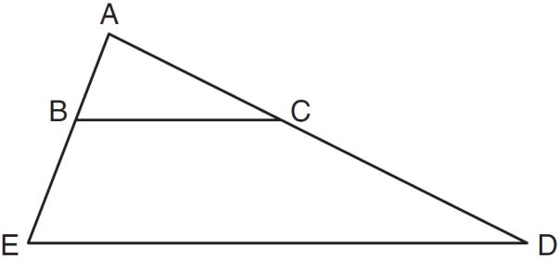

18. In the diagram below of , , , , and .

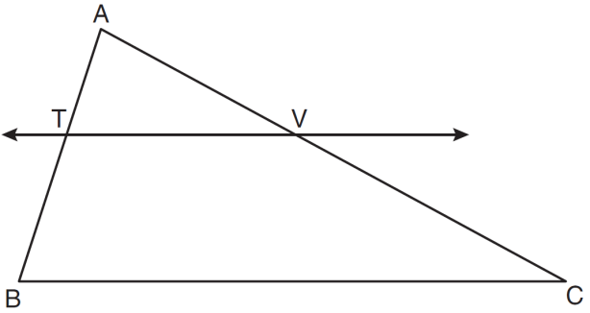

What is the length of ?

19.

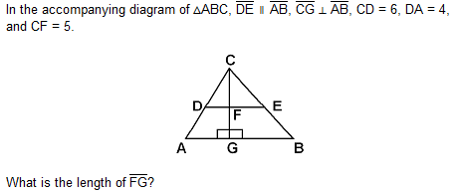

20. In the accompanying diagram of equilateral triangle *ABC*,  and .

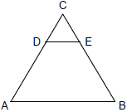

If *AB* is three times as long as *DE*, what is the perimeter of quadrilateral *ABED*?

21. In the diagram below of , with  and , .

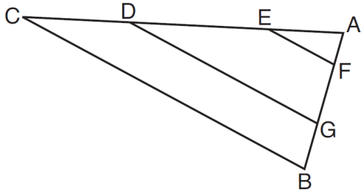

Which statement is *false*?

|  |  |
| --- | --- |
| 1) |  |
| 2) |  |
| 3) |  |
| 4) |  |

22.

